**EXP NO: 8: 16-BIT DIVISION**  
  
**AIM:**To write an assembly language program to  
implement 16-bit divided by 8-bit using 8085 processor.  
  
**ALGORITHM:**  
 1)      Read  
dividend (16 bit)  
2)      Read divisor  
3)      count<- 8  
4)      Left shift dividend  
5)      Subtract divisor from upper 8-bits of dividend  
6)      If CS = 1 go to 9  
7)      Restore dividend  
8)      Increment lower 8-bits of dividend  
9)      count <- count - 1  
10)  If count = 0 go to 5  
11)  Store upper 8-bit dividend as remainder and lower 8-bit as quotient  
12)  Stop  
  
**PROGRAM:**  
LDA 8501  
MOV B,A  
LDA 8500  
MVI C,00  
LOOP:CMP B  
JC LOOP1  
SUB B

INR C  
JMP LOOP  
STA 8503  
DCR C  
MOV A,C  
LOOP1: STA 8502  
RST 1  
  
  
 **INPUT:**

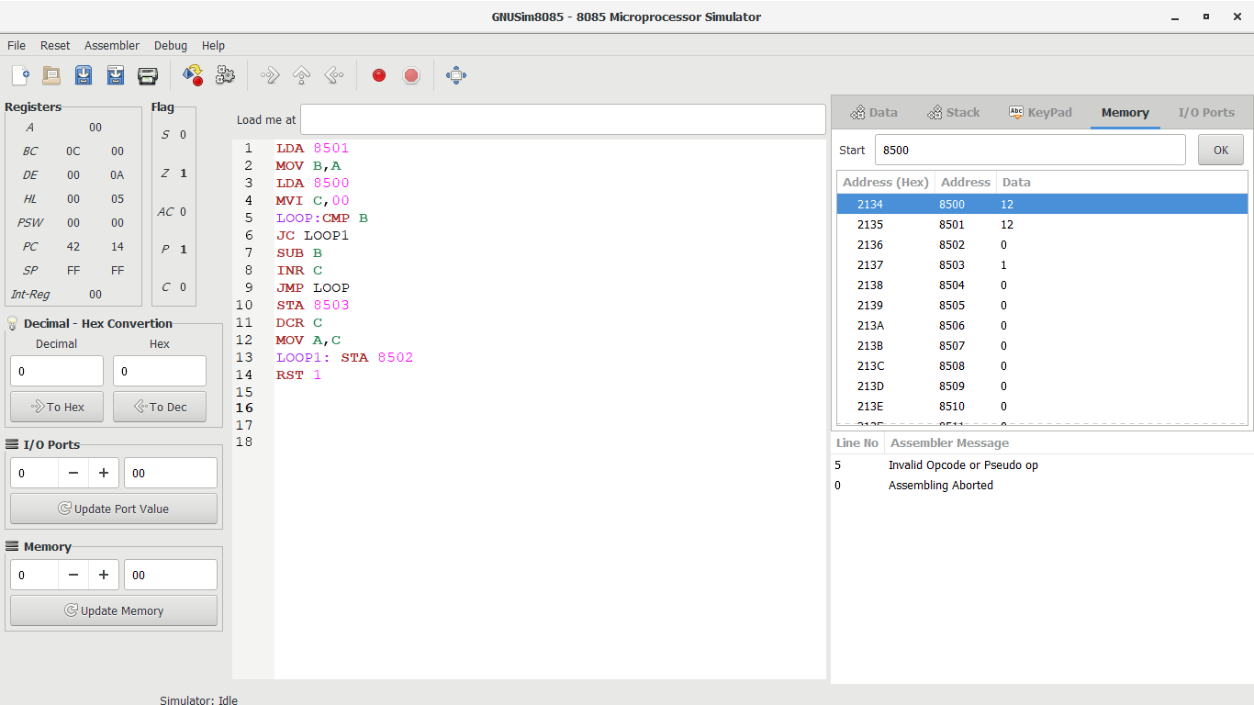

**OUTPUT:**

  
  
  
  
  
**RESULT:**Thus the program was executed successfully using 8085  
processor simulator.